1. Agenda:
   1. TO check if the provided msg id was processed earlier or not.
2. 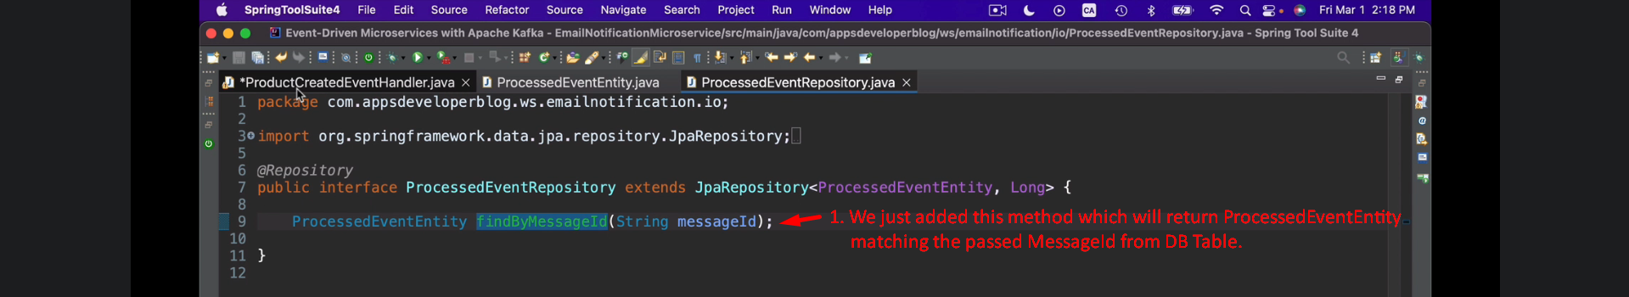
3. 